**P&P Home for the Elderly, 1030 W. 85th St., Los Angeles, CA 90044**

Telephone: (323) 789-1990 Fax: (323) 759-4567 TTY: Call 711 for Relay

Pre Applications for the Waitlist can be submitted on accesshousingla.org

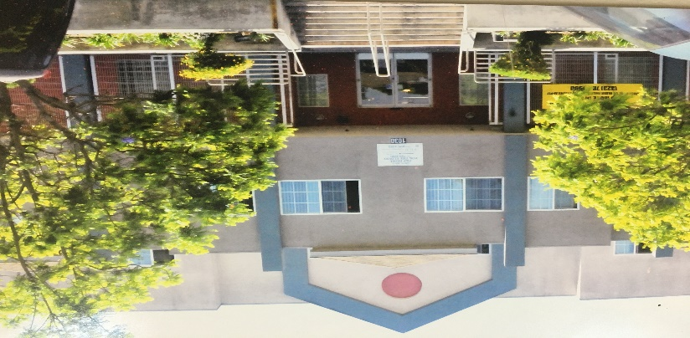

**The Waiting List Will be Open Beginning on April 30, 2024 and Stay Open until April 30, 2025**

P&P Home for the Elderly is a three story, 107-unit affordable apartment community for senior citizen located near the corner of Vermont Ave and Manchester Ave in the City of Los Angeles. All applicants must be at least 62 years old and have verifiable income at or below 50%, 60% or 120% of the Los Angeles median income. The property consists of single units only and no other size units are available. Accessible features at the site include a wheelchair ramp to the main entrance of the building, electronic entrance doors to the lobby and two elevators. The property also features underground parking, two recreation rooms and 24-hour attendants. The minimum income required for all applicants is $1,300.00 per month. The current rental rate is $750.00 a month and a $500.00 security deposit is required at move-in. Tenants are required to pay their own electricity, telephone, and cable TV. There is $30 application fee to apply for residency. Credit, Criminal and Eviction Check will be done on all applicants prior to approval.

**Applications must be obtained and submitted at the property office located at 1030 W. 85th St., Los Angeles CA 90044 between the hours of 11:00 AM and 3:00 PM Monday thru Friday or by email at pphome1030@gmail.com.** For further information regarding the site please call (323) 789-1990 during normal business hours. Inquiries about accessible features can also be done by reaching out at the address, email and phone number listed above.

**This Housing is offered without regard to race, color, national origin, sex, religion, ancestry, genetic information, source of income, age, marital status, familiar status, sexual orientation or preference, gender identity, or disability or any other basis prohibited by law.**

**Individuals with a disability have the right to ask for and receive reasonable accommodations**

**and to request auxiliary aids.**

 