FOR RENT!  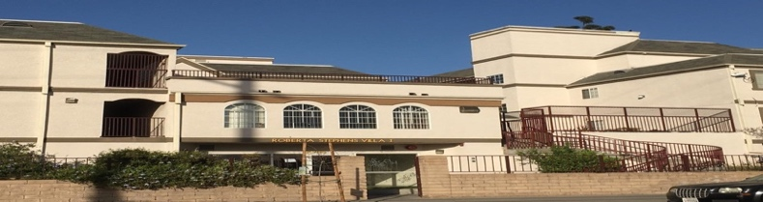  Roberta Stephens Villas 1 & 2  Conventional Unit Waiting List  Open: Friday, February 16, 2024 thru Monday, February 19, 2024.  Accessible Unit Wait List, OPEN NOW!  Conventional Waiting List :Open: 2bd/1bath: Conventional Unit in an Affordable Family Housing, AVAILABLE NOW!  Requirement: Rent $1,645.00 AMI 60% for Occupancy 2 people Max for Occupancy 4 people. Min income $52,980 to $60,540. *3 people @ 60%, income to qualify must be $60,540 to $68,100 per household. Section 8 Welcomed.  Address: 1035 East 27th Street, LOS ANGELES CA 90011  Requirement: Hearing and Vision: Rent $1,645.00 AMI 60% for Occupancy 2 people Max for Occupancy 4 people. Min income $52,980 to $60,540. *3 people @ 60%, income to qualify must be $60,540 to $68,100 per household. Section 8 Welcomed.  Address: 1113 East 27th Street, LOS ANGELES CA 90011  Central Air and Heating, Laundry Facility on site, Garage parking, balcony, Stove and Refrigerator.  Qualifications: Based on annual income and house hold size based on the Maximum Income Levels by the California Tax Credit Allocation Committee.* Applicants who qualify will be placed on the waiting list. Accessible Units and/or units with accessible features has a current waiting list, please email debora@ccscla.org, or call (323) 846-2500 x 1173.  Please apply at www.accesshousingla.org to be added to the Conventional Wait List and Accessible Unit Waiting List. Two alternative methods to receive and submit applications are as follows: via email applications to the resident manager Debora Parra, debora@ccscla.org or fax (323) 316-9944. For any additional request or information email debora@ccscla.org or contact the Resident Manager, Debora Parra at (323) 846-2500 x 1173, TTY number please use 711.  For any additional request or information email debora@ccscla.org, or contact the Resident Manager, Debora Parra at (323) 846-2500 x 1173, for TTY number please use 711.  “This housing is offered without regard to race, color, national origin, sex, religion, ancestry, genetic information, source of income, age, marital status, familial status, sexual orientation or preference, gender identity, or disability, or any other basis prohibited by law.”  “Individuals with a disability have the right to ask for and receive reasonable accommodation and to request auxiliary aids.”   | Roberta Stephens Villas 1 & 2  323 846-2500 x 1173  Roberta Stephens Villas 1 & 2  323 846-2500 x 1173  Roberta Stephens Villas 1 & 2  323 846-2500 x 1173  Roberta Stephens Villas 1 & 2  323 846-2500 x 1173  Roberta Stephens Villas 1 & 2  323 846-2500 x 1173  Roberta Stephens Villas 1 & 2  323 846-2500 x 1173  Roberta Stephens Villas 1 & 2  323 846-2500 x 1173  Roberta Stephens Villas 1 & 2  323 846-2500 x 1173  Roberta Stephens Villas 1 & 2  323 846-2500 x 1173  Roberta Stephens Villas 1 & 2  323 846-2500 x 1173  Roberta Stephens Villas 1 & 2  323 846-2500 x 1173  Roberta Stephens Villas 1 & 2  323 846-2500 x 1173  Roberta Stephens Villas 1 & 2  323 846-2500 x 1173  Roberta Stephens Villas 1 & 2  323 846-2500 x 1173

