Property based Section 8 Affordable Waiting List Opening

Sheridan South Apartments (Lexington A & B)

1531 W Adams Blvd. 2521 Juliet St.
7219 S San Pedro St. 2607 S Mansfield Ave. 10607 Kalmia St
Occupancy Standards Apply

You can request an application and check the availabilities for Accessible Units at
accesshousingla.org

Apartment Features
1 & 2 Bedroom Apartments with Stove and Refrigerator included

A person with a disability may request a reasonable accommodation (a reasonable change in policies), a reasonable structural modification, an accessible unit or the provision of auxiliary aids and services, in order to have equal access to a housing program. Please contact our staff.

For auditory assistance, contact can be made at no charge through the
California Relay Service:
TDD 1-800-735-2929 or 711

To request an application, you may contact us at:
310-205-2105 on Monday April 15, 2024 and Tuesday April 16, 2024, AlphaWL@21alphagroup.com
Or you may also scan the QR code below and enter yourself using Rent Café.
NO WALK INS
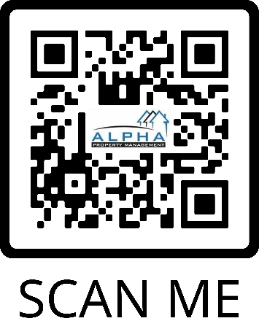
s

