# AFFORDABLE HOUSING COMMUNITY ACCEPTING APPLICATIONS

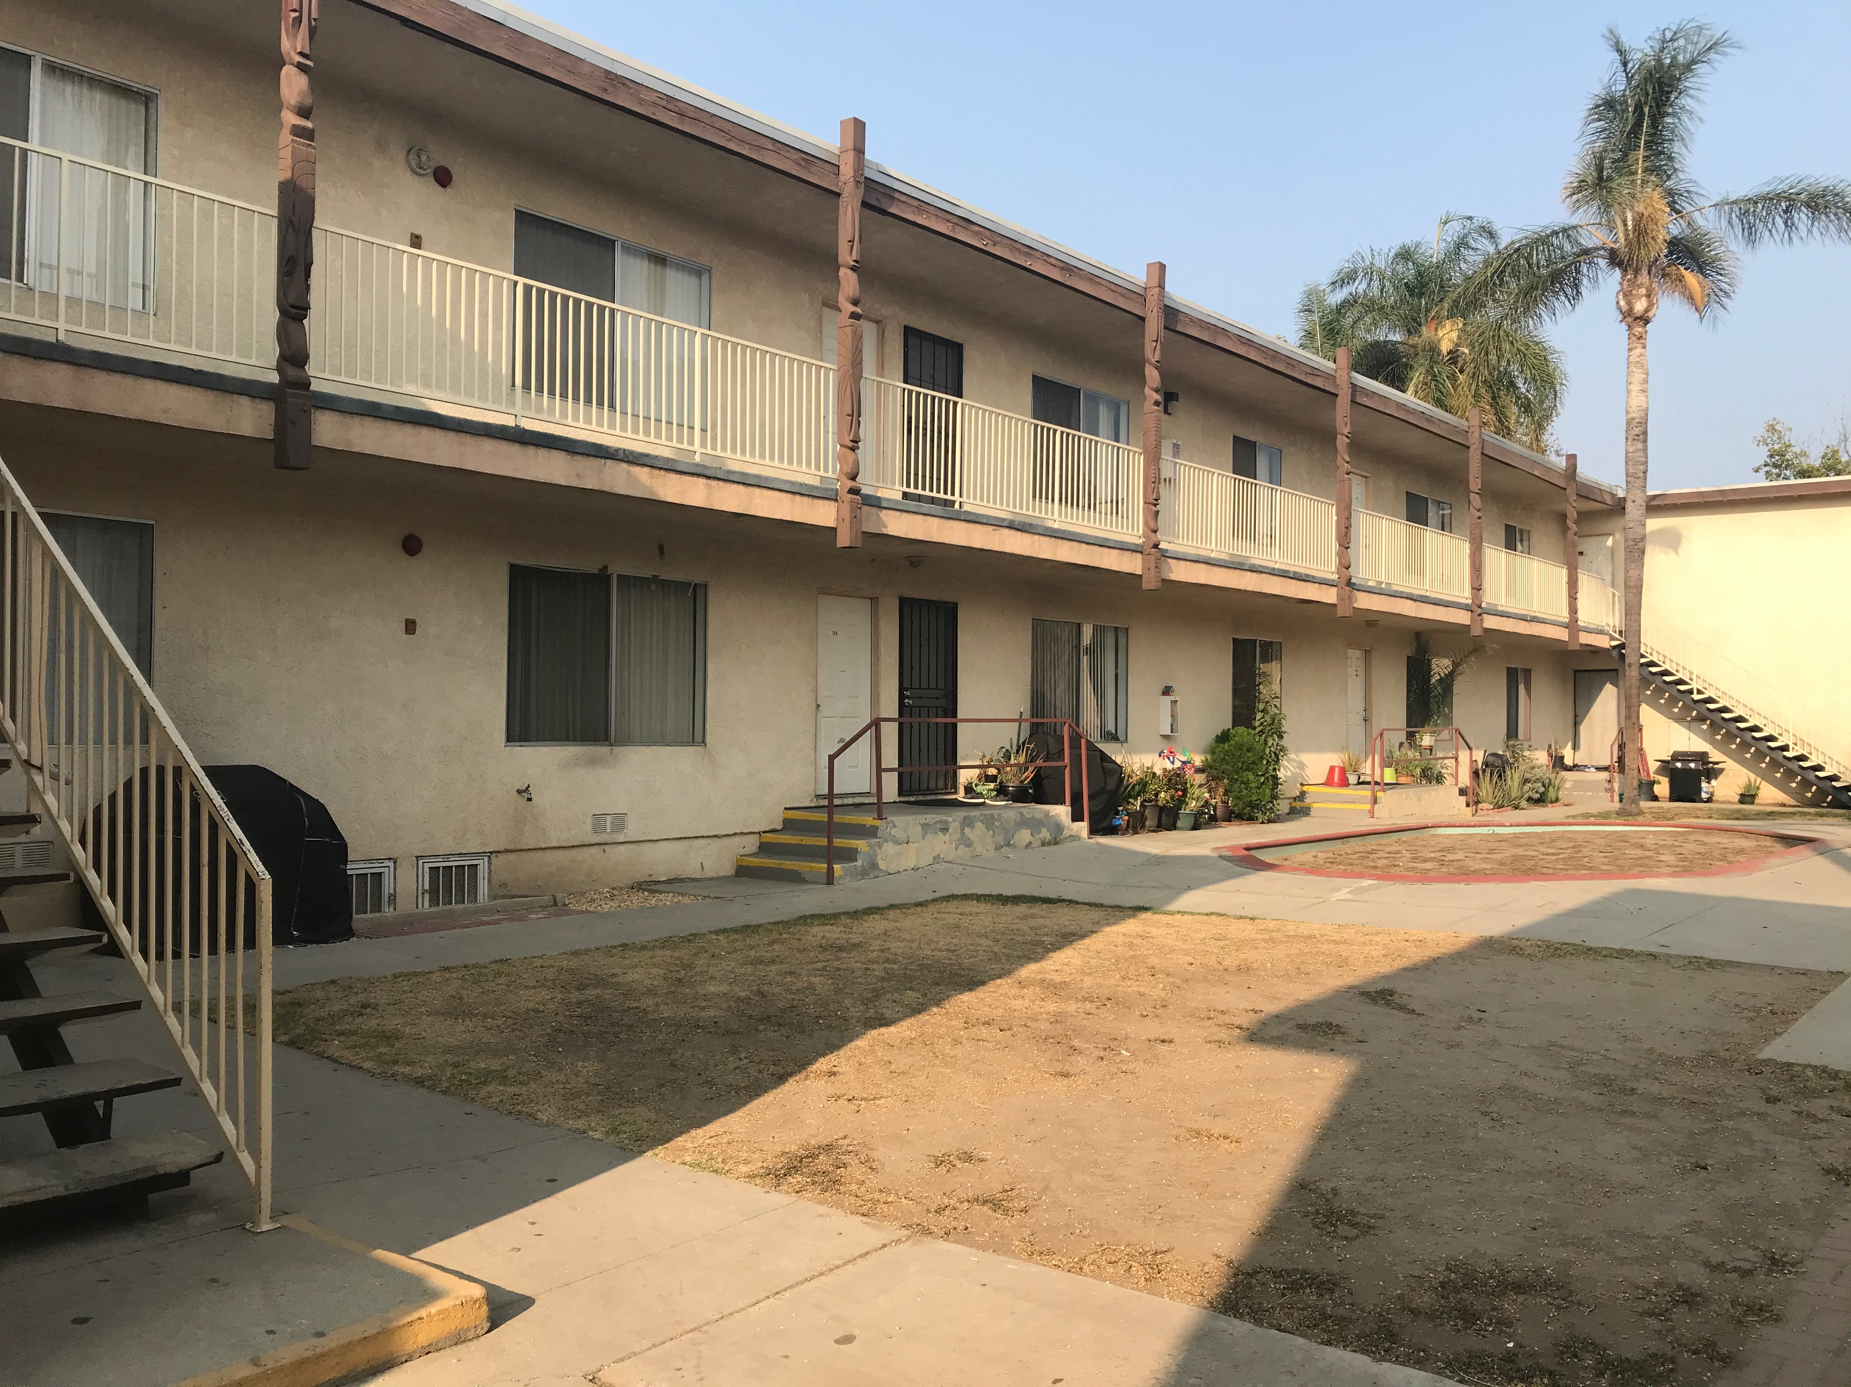

**Garcia Marquez**

**8735 Orion Avenue North Hills CA 91343**

We are now accepting application for 1 BD and 1 BR, 2BD and 2BR, 3BD and 2BR Apartments for our waiting list. Section 8 Program welcome. Eligibility for Garcia Marquez 8735 is determined by age, household size and income. Maximum income limits apply.

**Applications will be available for pick up or provided by US Mail and facsimile starting 11/01/2021 and MUST be returned in person, by US Mail or facsimile for an open waiting list.**

Garcia Marquez 8735

8920 Orion Ave #108, Rental Office North Hills CA 91343

PH: 818-830-0087. Fax: 818-893-5822

Email: ninoos.npic@gmail.com

Office Hours are Monday through Friday, 9 am to 5 pm

Telephone device for the hearing-impaired is TTY: (877) 735-2929. IF you have a disability that prohibits you from fully participating in this process please call (213) 627-5286 during the dates above, you will need to provide your name, mailing address, and phone number in order to obtain an application in the mail.

This housing is offered without regard to race, color, religion, sex, gender, gender identity and expression, family status, national origin, marital status, ancestry, age, sexual orientation, disability, source of income, genetic information, arbitrary characteristics, or any other basis prohibited by law