# AFFORDABLE HOUSING COMMUNITY ACCEPTING APPLICATIONS

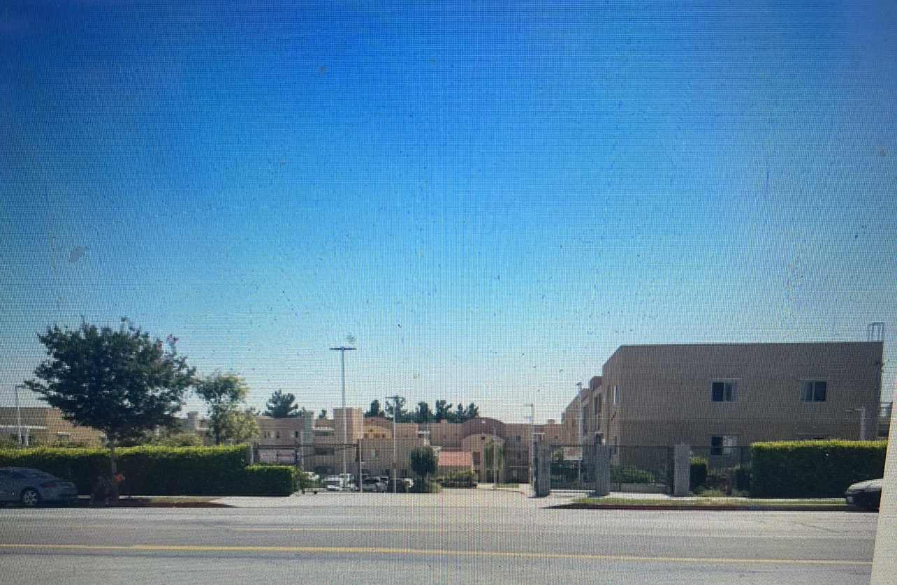

**WILLOW TREE VILLAGE L.P**

**12000 Foothill Blvd, Sylmar CA 91342**

We are now accepting application for our 4 BD and 2 1/2 BR Apartments for a limited number of immediate openings and for the waiting list. All units are subsidized under the Federal Section 8 Program. Eligibility for Willow Tree Village L.P Apartments is determined by age, household size and income. Maximum income limits apply.

**Applications will be available for pick up or provided by US Mail and facsimile and MUST be returned in person, by US Mail or facsimile to:**

WILLOW TREE VILLAGE L.P

12000 Foothill Blvd, Sylmar CA 91342

PH: 818-897-8465

Fax: 818-978-8355

Email: grasiela.npic@gmail.com

Office Hours are Monday through Friday, 8 am to 5 pm

Telephone device for the hearing-impaired is TTY: (877) 735-2929. IF you have a disability that prohibits you from fully participating in this process please call (213) 627-5286 during the dates above, you will need to provide your name, mailing address, and phone number in order to obtain an application in the mail.

This housing is offered without regard to race, color, religion, sex, gender, gender identity and expression, family status, national origin, marital status, ancestry, age, sexual orientation, disability, source of income, genetic information, arbitrary characteristics, or any other basis prohibited by law