**Are you a senior looking for quality, *affordable* housing?**

**Hollyview**

*A Retirement Housing Foundation Community*

5411 Hollywood Blvd.

Hollywood, CA 90027

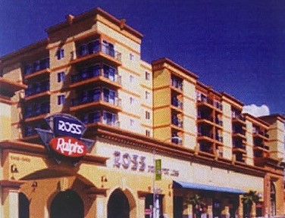

Accepting Applications May 1, 2022 -May 30, 2022

Hollyview is a 100-unit affordable housing community for seniors 55 years of age or older.

## One-Bedroom Apartments Include:

Bathroom w/ safety features

Full Kitchen with Energy Efficient Appliances

Vinyl Wood Plank Flooring

Central Heating & Air Conditioning

Utilities (resident pays for electricity)

Accessible units are available

## Building Amenities:

On-Site Management Staff

Elevators

Off-street parking

Community Room for Recreational Activities

Indoor, Individually locked mailboxes

Controlled Entry

Coin-operated Laundry Room

# Call for an application:

# 323-467-5117

# e-mail:hollyview@rhf.org

This housing offers accessible units and is offered without regard to race, color, religion, sex, gender, gender identity and expression, family status, national origin, marital status, ancestry, age, sexual orientation, disability, source of income, genetic information, arbitrary characteristics, or any other basis prohibited by law. Additional information about this community can be found at [www.rhf.org](http://www.rhf.org/) and [www.accesshousingla.org.](http://www.accesshousingla.org/)

An application for this community can be downloaded from [www.rhf.org](http://www.rhf.org/) or by calling 562-257-5100 and requesting one. Applications must be mailed to: RHF-Retirement Housing Foundation 911 N. Studebaker Rd., Long Beach, CA 90815 and received between May 1, 2022 and May 30, 2022 or they will not be considered.

People have the right to ask for and receive reasonable accommodations and physical modifications, including the right to ask for communications in alternative formats and for auxiliary aids and services, and how to make such requests.

Perry Glenn - 504 Coordinator Foundation Property Management, Inc.

911 N. Studebaker Road Long Beach, CA 90815-4900 562-257-5100 Fax: 562-257-5200 TDD: 800-545-1833 Ext. 359