# Bryson Family Apartments

Accepting Applications 03/01/2021 – 03/31/2021

**Affordable Housing: Open Wait List**

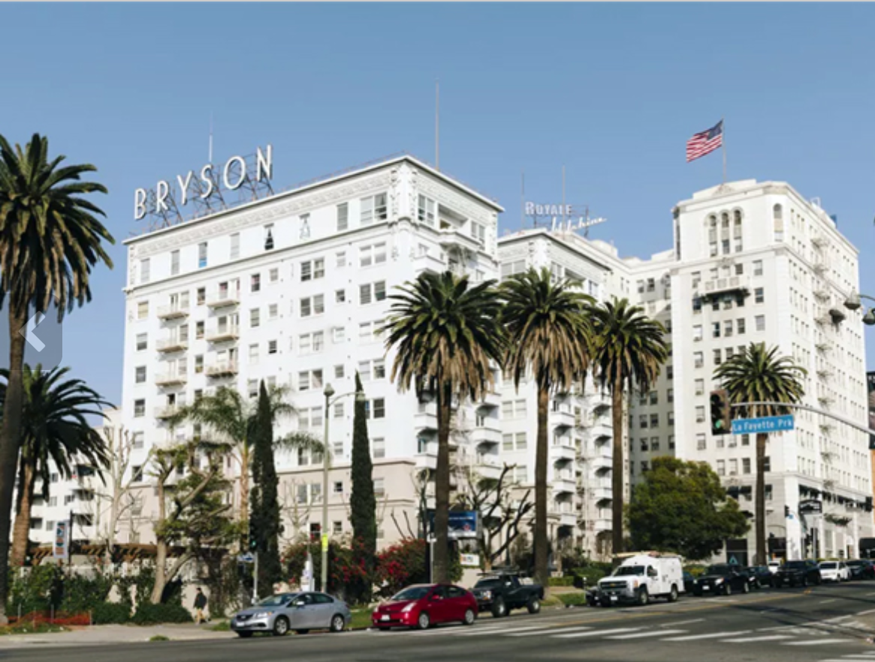

Bryson Family Apartments is a historic building in downtown Los Angeles along Wilshire Blvd offering (Studio), (1 BR), (2 BR), and (3 BR) units. The secured access community is conveniently located near public transportation and recreational areas. The complex is a smoke free community with updated kitchens. Bryson Family Apartments affordable housing to qualified applicants meeting low income and other program requirements.

**Community Features: Methods for Obtaining and Accepting Applications :**

* Secured entry access
* Smoke free community
* On-Site Laundry Room

Accepting Applications 03/01/2021 -03/31/2021

available **online** at:

Eahhousing.org/apartments/Bryson-family **and** AccessHousingLA.org o**r by mail**.

Only returned applications **postmarked** by 03/31/2021 will be accepted for waitlist placement.

To obtain an application packet in the **mail**, please call, email **or** submit a letter or postcard indicating your name, address and telephone number to:

Bryson Family Apartments

2701 W. Wilshire Blvd.

Los Angeles, CA 90057

Office: (323) 247-6764

BF-Management@eahhousing.org

TDD: (800) 735-2929 or CA Relay Service: 711

**Apartment Amenities:**

|  |  |  |  |
| --- | --- | --- | --- |
| Type | Sqr. Ft. | Rent | Occup. |
| Studio | 500 | $528-$824 | 1-2 |
| 1-Bdr | 700 | $464-$1,129 | 1-3 |
| 2-Bdr | 900 | $668-$971 | 2-5 |
| 3-Bdr | 1100 | $756-$1181 | 3-7 |

* Updated kitchen, range, refrigerator
* Walk-in closets
* High speed internet access
* Air conditioning, heating

This housing is offered without regard to race, color, national origin, sex, religion, ancestry, genetic information, source of income, age, marital status, familial status, sexual orientation or preference, gender identity, or disability, or any other basis prohibited by law.

A person with a disability may request a reasonable accommodation (a reasonable change in policies), a reasonable structural modification, an accessible unit or the provision of auxiliary aids and services, in order to have equal access to a housing program. If you or anyone in your household has a disability, and because of that disability requires a specific accommodation, modification or auxiliary aids or services to fully use our housing services, please contact our staff for a reasonable accommodation form. The use of a Reasonable Accommodation Form is not required.