Santa Monica & Vermont
Brand New Affordable Studio, 1-, 2- & 3-Bedroom Apartments in Los Angeles.
Pre-Applications Available Starting November 1, 2023 through November 30, 2023.
Occupancy expected to begin Spring 2024! Applications available for 15 studio, 31 one-bedroom, 40 two-bedroom and 5 three-bedroom apartments starting November 1, 2023!

Mobility/Hearing/Sight impaired households will have priority for 16 units designed for the mobility impaired and 10 units designed for the hearing/sight impaired.

A person with a disability may request a reasonable accommodation (a reasonable change in policies), a reasonable structural modification, an accessible unit or the provision of auxiliary aids and services, in order to have equal access to a housing program. If you or anyone in your household has a disability, and because of that disability requires a specific accommodation, modification or auxiliary aids or services to fully use our housing services, please contact our staff for a reasonable accommodation form.

For up-to-date information, call (213) 772-7606. Telephone Device for the Deaf: (888) 877-5379 or California Relay Service (711)
JSCo BRE# 654405

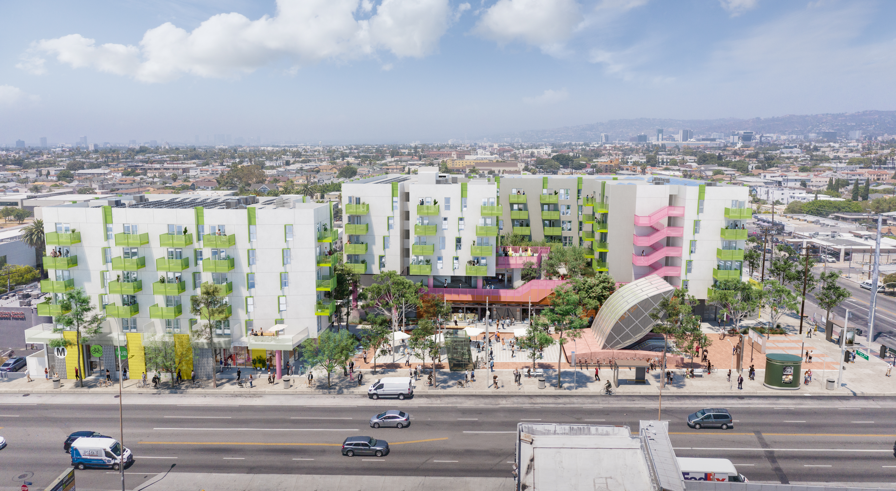
1021 N. Vermont Avenue, Los Angeles, CA 90029
Apartment Amenities:  - Fully equipped  Energy Star Appliances Refrigerator Included  - Garbage Disposal  - Air Conditioning | Community Amenities:  - Landscaped Courtyard Areas  - Playground  - Multiple Community Rooms  - Barbeque Area  - Locked Bicycle Storage Rooms

Accessible units include: Accessible bath tub with removable seat, Grab Bars, Toilet with Grab Bars, and Wheelchair accessible Kitchen and Bathroom sinks and Talking Smoke/Carbon Monoxide Alarms with Flashing Light (only for Communication Units).

To fill out an application, please visit: www.SMVApts.com

To obtain an application packet in the mail or via email, please send an email to: Donna Lambe, Regional Manager at SMV@jsco.net you may call: (213) 787–2760. Applicants requesting an accessible unit can also show interest for an accessible unit via accesshousingla.org

All applications received by 11:59 PM PST November 30, 2023 will be entered into the lottery. If you are unable to participate in this process DUE TO A DISABILITY, you may call: (213) 787–2760 or email SMV@jsco.net

Unit Size | Accessible Unit Type | Units  Available | Household  Size | Rent*  50% AMI
Studio | Mobility | 3 | 1-2 | $1,103
Studio | Hearing/Vision | 1 | 1-2 | $1,103
1 Bedroom | Mobility | 4 | 1-3 | $1,182
1 Bedroom | Hearing/Vision | 3 | 1-3 | $1,182
2 Bedroom | Mobility | 8 | 2-5 | $1,418
2 Bedroom | Hearing/Vision | 5 | 2-5 | $1,418
3 Bedroom | Mobility | 1 | 4-7 | $1,576
3 Bedroom | Hearing/Vision | 1 | 4-7 | $1,576

Maximum Gross Annual Income (effective 04/01/2023)
Household Size | 50% AMI*
1 | $44,150
2 | $50,450
3 | $56,750
4 | $63,050
5 | $68,100
6 | $73,150
7 | $78,200
Minimum monthly income is 2 x rent
*Income and Rent Limits Subject to Change
Rent and income limits are subject to change without notice. Occupancy standards may vary depending on subsidy or other program guidelines. There is no minimum income requirement for applicants with a Section 8 Voucher. Income and other restrictions apply. Affordable rents are restricted in accordance with the Low-Income Housing Tax Credit (LIHTC) program and other Regulatory Agreements.

