    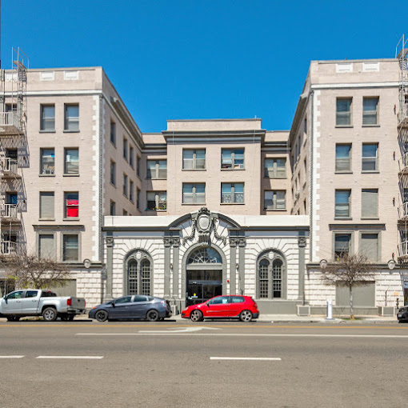  - accepting applications September 6, 2024 – October 4, 2024  Chancellor Apts  Household Size 1 Person 2 Person  60% Income Limit $ 58,260 $ 66,540  30% Income Limit $ 29,130 $ 33, 270  **Accepting applications for Conventional Wait list only; no accessible units available at this property**  ** Minimum and maximum income limits apply**  This housing is offered without regard to race, color, religion, sex, gender, gender identity and expression, familial status, national origin, citizenship status, immigrant status, primary language, marital status, ancestry, age, sexual orientation, disability, source of income (including receipt of Section 8 and other similar vouchers), genetic information, military or veteran status, arbitrary characteristics, or any other basis currently or subsequently prohibited by law.  Individuals with a disability have the right to ask for and receive  reasonable accommodations and to request auxiliary aids.  Chancellor Apartments currently does not have any certified  accessible units but any applicants who would like to request an  accessible unit may be added to a waiting list if an accessible unit  becomes available in the future. Additional information may be  found at www.accesshousingla.org or by inquiring directly with the  property using the above methods of contact. | Amenities: Community Room, Gym Equipment, On-site Laundry  ____  Community: Walking distance from H-Mart, Jons, Restaurants, Schools  ____  Affordable Housing!  ____  The owner pays for all utilities!  ____  The application can be emailed, faxed, or received in person with an appointment.  Chancellor Apartments  3191 W 7th Street  Los Angeles, CA 90005  213-487-0915  213-277-9379 (TTY)  chancellorapts.com  Selena Pascual chancellor.info@fpimgt.com  Monday & Friday  9AM – 5PM

