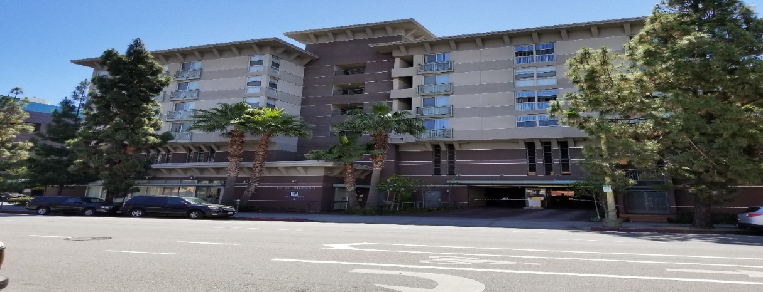
Property has 61 units: 11/4-bdrs, 20/3bdrs, 30/2bdrs.
This housing is offered without regard to race, color, national origin, sex, religion, ancestry, genetic information, source of income, age, marital status, familial status, sexual orientation or preference, gender identity, or disability, or any other basis prohibited by law. Individuals with a disability have the right to ask for and receive reasonable accommodations and to request auxiliary aids.
Rental applications available at the property’s rental office or at Mercyhousing.org. Please reach out to site staff if you prefer a rental application be emailed, faxed and or mailed out to you. You may also apply through accesshousingla.org
Amenities:
- Playground
- Laundry room
- Limited Parking
- Entry access control
- Community room

Application available for Mobility and Hearing/Vision units.

