

Fickett Towers Senior Apartments Waiting List Open Studio &1-Bedroom Units

*JOIN OUR WAITING LIST TODAY*

***COMMUNITY FEATURES:***

* Professional Management
* 24/7 Emergency Maintenance
* Studio & One Bedroom Apartment Homes
* Elevator
* Water, Sewer, Trash & Electric Included
* Air Conditioner
* Stove & Refrigerator
* Microwave
* Pull Cords
* On-Site Laundry Facility
* Community Room
* Fitness Center
* Computer Room
* Library
* Service Coordinator

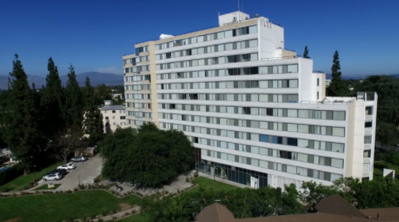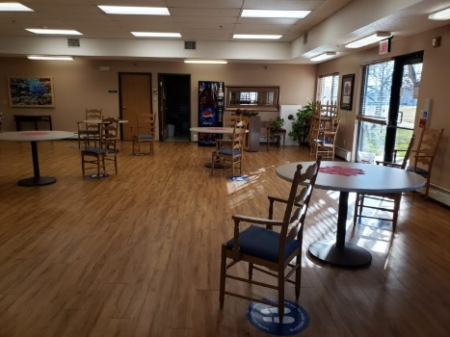

 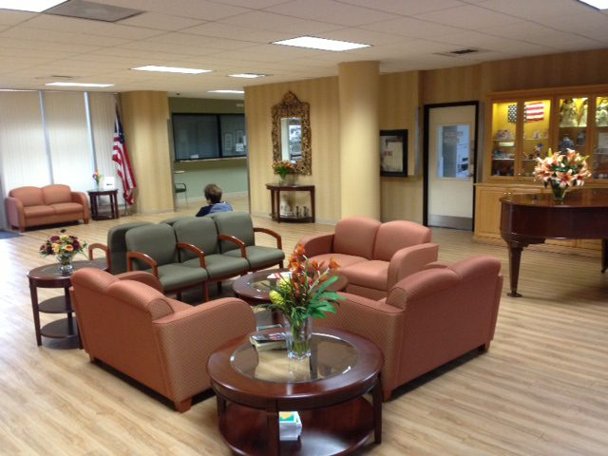

HOW TO APPLY: Mail, Email or drop off completed signed documents staring Feb 6th 2023 & No Later than Feb 28th 2023

* Come to the office to fill out an application, or you can call, or email, to request an application by mail or by email.
* MUST BE 62 YEARS OF AGE OR OLDER.
* MUST BE LOW INCOME.
* Must meet screening criteria, including credit, criminal background, and sex offender check.

HOW TO APPLY FOR OUR ACCESSIBLE UNITS:

* You may also submit an application for the Accessible Unit Waiting List at lahousing.lacity.org

Individuals with a disability have the right to request and receive reasonable accommodations, including the right to ask for auxiliary aids and services, communications in alternative formats, as well as information on how to make such requests.

This housing is offered without regard to race, color, religion, sex, gender, gender identity and expression, familial status, national origin, citizenship status, immigrant status, primary language, marital status, ancestry, age, sexual orientation, disability, source of income (including receipt of Section 8 and other similar vouchers), genetic information, military or veteran status, arbitrary characteristics, or any other basis currently or subsequently prohibited by law.

California Commercial Investment Group does not discriminate on the basis of disability status in the admission or access to; or treatment of; or employment in; its federally assisted programs and activities. The person named below has been designated to coordinate compliance with nondiscrimination requirements contained in the Department of Housing and Urban Development’s regulations implementing Section 504 (24CFR, part 8 dated June 2, 1988).

Scott Heaton at 4530 E. Thousand Oaks Blvd., Ste 100, Westlake Village, CA 91362. Email: [Scott@ccinvest.com](mailto:Scott@ccinvest.com), English Voice/TTY: 800-855-7100, Spanish Voice/TTY: 800-855-7200 (Included Spanish-to-Spanish and Translation from English to Spanish), Speech-to-Speech (STS): 800-855-7300, Visually Impaired Assisted STS: 800-855-7400.

Now accepting applications for households 62 years of age or older

Starting February 6 through February 28, 2023

From (10AM) to (4:30PM)

14801 Sherman Way

Van Nuys, CA 91405

(818) 988-8625

Email: FickettTowers@ccinvest.com

CCINVEST.COM